**Experimental Device for Measuring FDI and Biceps Brachii Muscle Activity**

a custom experimental setup similar to the provided images (end of the doc) but with the following modifications:

1. For left and right hands **\*2**
2. **Base Board**: A sturdy board, slightly longer than the forearm, to serve as a stable base. The forearm should rest comfortably on the board, with an optional elbow support.
3. **Arm Positioning**:
   * The **elbow should be flexed at an angle of 90° to 115°**.
   * The **forearm should be in a pronated position (palm facing down)**.
4. **Adjustable Wrist Straps**:
   * One **fixed, adjustable strap at the wrist**.
   * A second **fixed, adjustable strap 10 cm behind the wrist**.
   * These straps secure the forearm while allowing controlled biceps activation.
5. **Finger Restraint**: A **comfortable strap** secures the middle finger to the little finger at the front end to prevent unintended hand movements.
6. **Stopper for Thumb and Index Finger**:
   * A **thumb stopper** and an **index finger stopper** to keep these fingers in a fixed position.
   * This ensures precise force application without unwanted hand displacement.

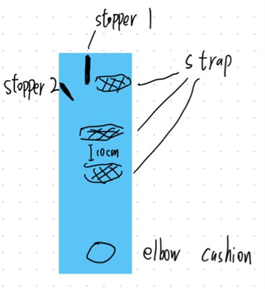This setup ensures proper stabilization of the arm and hand while allowing controlled activation of both the **first dorsal interosseous (FDI) and biceps brachii (BB) muscles**. Please use materials that are comfortable for participants while maintaining rigidity for accurate measurements.

Example devices

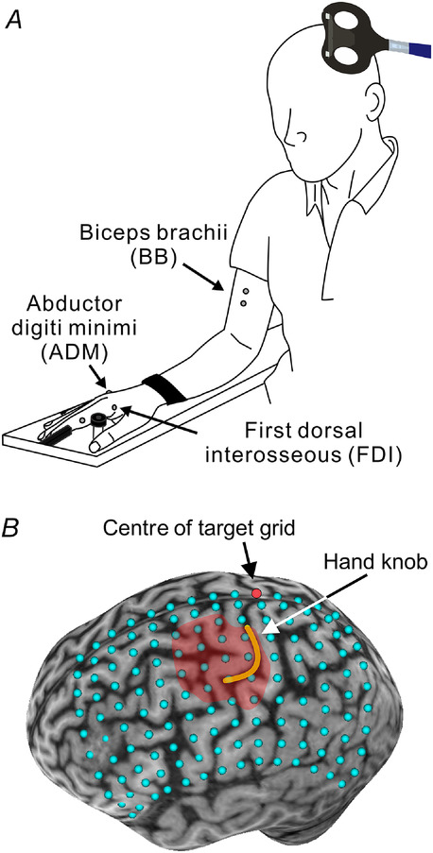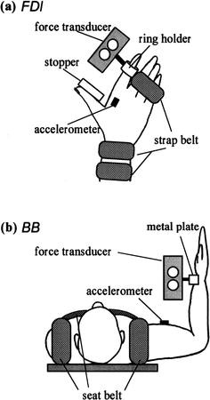

1. schematic illustration of the participant's posture during the experiments.
2. the elbow flexed by 90°-115°, the forearm pronated, and the wrist strapped to an armrest，
3. middle to little fingers were immobilized with strap belts
4. The index finger and thumb were restricted with a ‘stopper’
5. Example of comfort part

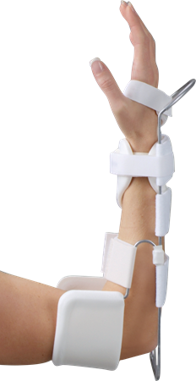

[Akataki et al., 2003] Akataki, K., Mita, K., Watakabe,M., and Itoh, K. (2003). Mechanomyographic responses during voluntary ramp contractions of the human first dorsal interosseous muscle. European journal of applied physiology, 89:520–525.

[Tazoe and Perez, 2021] Tazoe, T. and Perez, M. A.(2021). Abnormal changes in motor cortical maps in humans with spinal cord injury. The Journal of physiology, 599(22):5031–5045.